Yield Ladder and CTD Bond
Piecewise quadratic approximation for yield ↔ price conversion

QFI Algo does bond yield-price conversion (and vice versa) via a DBAnalytics library. DBAnalytics is an Excel based analytics C++ library, algo has to send requests in the form of spreadsheet liked objects to DBAnalytics (it looks a bit like Daiwa analytics library). The round trip can be a bit slow if price yield conversion is called on every tick. This document layouts a fast piecewise quadratic approximation in price domain to optimize performance of yield-price conversion. First of all, terminology :

• approximation in price domain : price is x-axis, model as function y = f(p), this is what we do
• approximation in yield domain : yield is x-axis, model as function p = f⁻¹(y)
• both y = f(p) and p = f⁻¹(y) are montonic decreasing function

Secondly, yield ladder is not a yield curve. Yield curve is a term structure that covers range of maturities and hence range of bonds, whereas yield ladder is only associated to one bond, with one fixed maturity and one fixed coupon. What algo does is to ask DBAnalytics during startup, for about 40 sample points in the price-yield function, each include :

• bond yield
• bond price
• first order derivative of price w.r.t yield, a.k.a. price-value-per-basis-point PVBP

Algo does not do any least square regression, it just approximates around the sample points with Taylor expansion up to 2 degree. In the following figure, red dots are sample points (called anchors), uniformly spaced in yield axis, but unevenly spaced in price axis. When we do yield ↔ price conversion we need to start with finding the nearest anchor. Boundary between two anchors in price axis is called boundary price. Quadratic Taylor expansion around anchor doesnt guarantee continuity at boundary price, hence we can see jumps. Remind again there is no quadratic approximation in yield domain, it is done in price domain only. The whole approximation is called yield ladder.

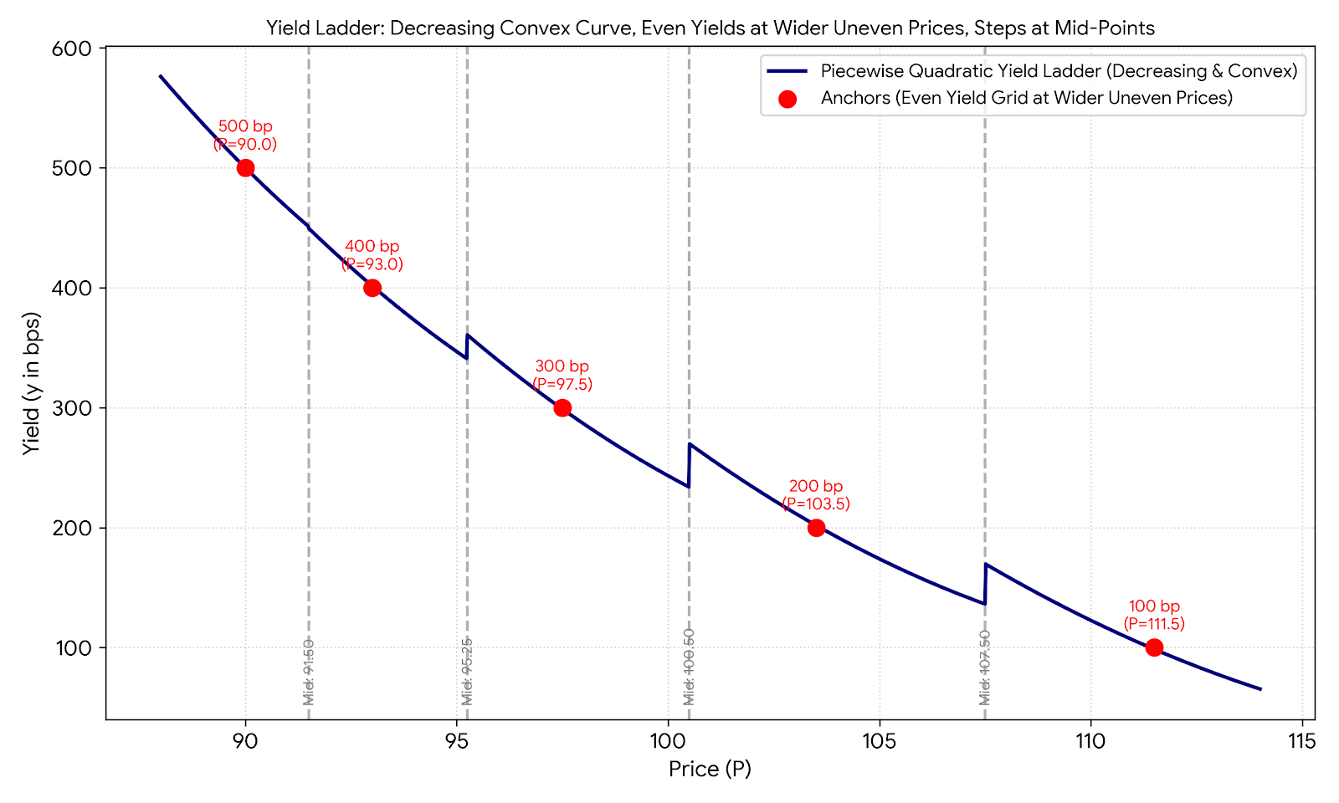

Question 1 : Can we do quadratic approximation in both price and yield domain? Like this :

• for price to yield conversion, approximate y = f(p)
• for yield to price conversion, approximate p = g(y)
• answer is NO, as we cannot guarantee function is inversible : p ≠ g(f(p))

Question 2 : Can we use cubic spline instead of piecewise quadratic? Cubic spline can ensure continuity, while piecewise quadratic results in discontinuity at mid prices.

• answer is YES, but it is more difficult to inverse cubic equation, it needs either :
iterative solution, like Newton method (slow)
branchy solution, like Cardano formula (not stable?)
both are not preferred, as compared to simple closed-form quadratic roots (we will see later)

Construction of yield ladder
Firstly, start with evenly spaced yield anchor. DBAnalytics calls all start with namespace dba.

$y_{0}$ = dba::bond_yield$(p_{previous_close})$ dba solves for yield given price, using Newton method
$y_{n}$ = $y_{0}+nh$ $∀n∈[-N,N]$
$h$ = yield step size for example, 0.0001 or 1bp

For each yield anchor, request bond price and the first order derivative of bond price from DBAnalytics. Function bond_PVBP (price value per basis point) returns -∂p/∂y by definition. Approximate second order derivative of bond price using central finite difference.

$p_{n}$ = dba::bond_price$(y_{n})$ hence y_{n} is evenly spaced, while p_{n} is not
${p'}_{n}$ = -dba::bond_PVBP$(p_{n})$
${p"}_{n}$ ≈ $\frac{{p^{'}}_{n+1}-{p^{'}}_{n-1}}{2h}$

Since we approximate function y = f(p), not p = g(y), hence we need to know the derivative of yield w.r.t. price, not the other way round.

$\frac{dy}{dp}$ = $\frac{1}{p'}$
$\frac{d^{2}y}{dp^{2}}$ = $\frac{d}{dp}\frac{1}{p'}$
= $-\frac{1}{p'2}\frac{dp'}{dp}$
= $-\frac{1}{p'2}\frac{dp'}{dy}\frac{dy}{dp}$
= $-\frac{1}{p^{'}2}p"\frac{1}{p^{'}}$ since $\frac{dp'}{dy}=p"$ and $\frac{dy}{dp}=\frac{1}{p^{'}}$
= $-\frac{p"}{p^{'}3}$

Taylor series expansion of y = f_{n}(p) around p_{n} is

$y$ = $f_{n}(p)$
= $y_{n}+{\left.\frac{dy}{dp}\right|}_{y_{n}}\left(∆p\right)+\frac{1}{2}{{\left.\frac{d^{2}y}{dp^{2}}\right|}_{y_{n}}\left(∆p\right)}^{2}$
= $y_{n}+\frac{1}{{p'}_{n}}\left(∆p\right)-\frac{1}{2}\frac{{p"}_{n}}{{{p'}_{n}}^{3}}{\left(∆p\right)}^{2}$
= $y_{n}+a_{n}\left(∆p\right)+b_{n}{\left(∆p\right)}^{2}$ where $a_{n}=\frac{1}{{p'}_{n}}$ and $b_{n}=-\frac{1}{2}\frac{{p"}_{n}}{{{p'}_{n}}^{3}}$
$∀p∈\left[dba::bond_price\left(\frac{y_{n}+y_{n-1}}{2}\right),dba::bond_price\left(\frac{y_{n}+y_{n+1}}{2}\right)\right]$
anchor_{n} = $\{p_{n},y_{n},a_{n},b_{n}\}$

Therefore we need to cache array of boundary prices and array of anchors.

anchors = $\left\{…dba::bond_price\left(\frac{y_{n}+y_{n-1}}{2}\right)…\right\}$
boundary = $\left\{…\left\{p_{n},y_{n},a_{n},b_{n}\right\}…\right\}$

Besides, we can approximate DV01 as well :

$\frac{dy}{dp}$ = $\frac{dy}{d∆p}\frac{d∆p}{dp}$ chain rule
= $\frac{dy}{d∆p}$ since $\frac{d∆p}{dp}=\frac{d(p-p_{n})}{dp}=1$
= $\frac{d}{d∆p}(y_{n}+a_{n}\left(∆p\right)+b_{n}{\left(∆p\right)}^{2})$
= $a_{n}+{2b}_{n}∆p$

DV01(p) = $-\frac{dp}{dy}$
= $-\frac{1}{a_{n}+{2b}_{n}∆p}$

Applying yield ladder - price to yield conversion
Given price p, the first step is to find the nearest anchor, which can be done by a linear scan of boundary array. An optimization technique we can apply is to cache the index in the boundary array for next call of price to yield conversion. This helps because one yield ladder is associated to one bond, when a yield ladder is used to perform price to yield conversion repeatedly, the price of the bond normally does not jump across two consecutive invocation, starting searching from sticky index gives us a fast match. Once the nearest anchor is found, suppose it is n, then yield can be obtained easily :

$y$ = $f_{n}(p)$
= $y_{n}+a_{n}\left(∆p\right)+b_{n}{\left(∆p\right)}^{2}$
= $y_{n}+a_{n}\left(p-p_{n}\right)+b_{n}{\left(p-p_{n}\right)}^{2}$

DV01(p) = $-\frac{1}{a_{n}+{2b}_{n}∆p}$
= $-\frac{1}{a_{n}+{2b}_{n}(p-p_{n})}$

Applying yield ladder - yield to price conversion
Given yield y, the nearest anchor can be easily found (without linear scan) by O(1) rounding :

$n$ = $round\left(\frac{y-y_{-N}}{h}\right)$
$n$ = $clamp\left(0,2N\right)$

Remember to clamp index n within [0,2N] to avoid accessing outside array. Then we have to solve the selected quadratic equation for ∆p. The quadratic equation and its closed form solution are :

$y$ = $y_{n}+a_{n}\left(∆p\right)+b_{n}{\left(∆p\right)}^{2}$
$0$ = $b_{n}{\left(∆p\right)}^{2}+a_{n}\left(∆p\right)-({y-y}_{n})$
$∆p$ = $\frac{-a_{n}±\sqrt{a_{n}^{2}+4b_{n}({y-y}_{n})}}{2b_{n}}$ we pick -ve sign because the other one diminished
= $\frac{-a_{n}-\sqrt{a_{n}^{2}+4b_{n}({y-y}_{n})}}{2b_{n}}$ $\frac{-a_{n}+\sqrt{a_{n}^{2}+4b_{n}({y-y}_{n})}}{2b_{n}}≈\frac{-a_{n}+\sqrt{a_{n}^{2}}}{2b_{n}}≈0$ since ${y≈y}_{n}$
$p$ = $p_{n}+∆p$

Brainstorming alternative models with copilot [20261015]
Continuity class : C1 and C0 model

The piecewise quadratic model introduced in previous section exhibits yield discontinuity at boundary points, this is thus called C-1 class model as it provides no continuity at all. We will now introduce two other piecewise quadratic models (as brainstormed with copilot), namely C1 and C0 model to solve the discontinuity issue. C2 model is actually the cubic spline we can usually see in yield curve modelling.

C1 model
Now we replace the N anchors with N nodes, they are called nodes instead of anchors because they are now the end points of quadratic segments (recall anchors are centre of quadratic segments). There are N-1 segments and hence 3(N-1) parameters, we need 3(N-1) data to solve for all parameters. This is called a C1 model because it ensures continuity in yield and the first order derivative. For segment n, it has to match yield at two end points, and match slope with that of previous segment :

$f_{n}\left(p_{n}\right)$ = ${\left.a_{n}{\left(∆p\right)}^{2}+b_{n}\left(∆p\right)+c_{n}\right|}_{∆p=0}$ = $dba ::bond_price\left(y_{n}\right)$
$f_{n}(p_{n+1})$ = ${\left.a_{n}{\left(∆p\right)}^{2}+b_{n}\left(∆p\right)+c_{n}\right|}_{∆p=p_{n+1}-p_{n}}$ = $dba::bond_price\left(y_{n+1}\right)$
${f'}_{n}(p_{n})$ = ${f'}_{n-1}(p_{n})$

The third criteria can be written as :

${f'}_{n}(p_{n})$ = ${f'}_{n-1}(p_{n})$
→ $2{\left.a_{n}∆p+b_{n}\right|}_{∆p=p_{n}-p_{n}}$ = $2{\left.a_{n-1}∆p+b_{n-1}\right|}_{∆p=p_{n}-p_{n-1}}$

There are 3(N-1)-1 data, with a missing data because the first segment does not have a previous segment for it to match with. Solution to the missing data is to use DBAnalytics PVBP for matching slope of first segment. Therefore the implementaton is like bootstrapping (no matrix inverse is needed) :

solve quadratic 0 with $dba ::bond_price\left(y_{0}\right)$ $dba::bond_price\left(y_{1}\right)$ $dba::bond_PVBP\left(y_{0}\right)$
solve quadratic 1 with $dba ::bond_price\left(y_{1}\right)$ $dba::bond_price\left(y_{2}\right)$ ${f'}_{0}(p_{1})$
solve quadratic 2 with $dba ::bond_price\left(y_{2}\right)$ $dba::bond_price\left(y_{3}\right)$ ${f'}_{1}(p_{2})$
…
solve quadratic N-2 with $dba ::bond_price\left(y_{N-2}\right)$ $dba::bond_price\left(y_{N-1}\right)$ ${f'}_{N-3}(p_{N-2})$

Advantages of this C1 proposal is that :
• not dependent on noisy $dba::bond_PVBP$ except one point
• not dependent on noisy $dba::bond_convexity$
• no least square regression
• no discontinuity in yield (i.e. no jump)
• no discontinuity in slope (i.e. no kink)
• closed form inverse

There is a major disadvantage. As it is using bootstrapping, starting with noisy $dba::bond_PVBP\left(y_{0}\right)$, error can accumulate through the segments. Previous segment always forces next segment to follow its slope, the curve may flip flop in slope and end up wobbling along price axis. At some point, it may even create local minimum in function, breaking the monotonic decreasing price-yield characteristic, which is even worse than discontinuity.

C0 model
This is similar to C1 model, just with changes in how parameters are calibrated. Again there are N nodes, hence N-1 quadratic segments, 3(N-1) parameters. This is called C0 model because it ensures continuity in yield only, no first order derivative continuity. For segment n, it has to match yield at two end points, and match slope at one end with DBAnalytics :

$f_{n}\left(p_{n}\right)$ = ${\left.a_{n}{\left(∆p\right)}^{2}+b_{n}\left(∆p\right)+c_{n}\right|}_{∆p=0}$ = $dba ::bond_price\left(y_{n}\right)$
$f_{n}(p_{n+1})$ = ${\left.a_{n}{\left(∆p\right)}^{2}+b_{n}\left(∆p\right)+c_{n}\right|}_{∆p=p_{n+1}-p_{n}}$ = $dba::bond_price\left(y_{n+1}\right)$
${f'}_{n}(p_{n})$ = $2{\left.a_{n}∆p+b_{n}\right|}_{∆p=p_{n}-p_{n}}$ = - $dba::bond_PVBP\left(y_{n}\right)$

There are 3(N-1) data, good enough to solve all parameters. As there is no inter-segment equation, the implementation can be done without bootstrapping nor matrix inverse.

solve quadratic 0 with $dba ::bond_price\left(y_{0}\right)$ $dba::bond_price\left(y_{1}\right)$ $dba::bond_PVBP\left(y_{0}\right)$
solve quadratic 1 with $dba ::bond_price\left(y_{1}\right)$ $dba::bond_price\left(y_{2}\right)$ $dba::bond_PVBP\left(y_{1}\right)$
solve quadratic 2 with $dba ::bond_price\left(y_{2}\right)$ $dba::bond_price\left(y_{3}\right)$ $dba::bond_PVBP\left(y_{2}\right)$
…

Advantages of this C0 proposal is that :
• not dependent on noisy $dba::bond_convexity$
• no least square regression
• no discontinuity in yield (i.e. no jump)
• no curve flip-flop (wobbling)
• closed form inverse

Comparison from C-1 to C2
Continuity class C0-C2 are also known as spline, as they exhibit different degree of continuity.

In the following :
• “match” means calibrating parameter to match data provided by DBAnalytics
• “continuous” means calibrating parameter to match with that in previous / next segment

model class implementation inverse issue
piecew quad C-1 Taylor expansion around anchor closed form quad jump, kink
piecew quad C1 match yield at 2 ends, continuous slope closed form quad wobble
piecew quad C0 match yield at 2 ends, match slope at 1 end closed form quad kink
piecew cubic C2 match yield at 2 ends, continuous slope convexity Newton method slow

